|  |  |
| --- | --- |
| **ITEM** | **433-437 Canterbury Road, Campsie** |
| **DEVELOPMENT** | **Demolition of existing structures and the construction of a three-storey** **mixed-use building with three levels of basement car parking, associated landscaping and site works.** |
| **FILE** | **PPSSSH-112 – DA-286/2022** |
| **ZONING** | **B6 Enterprise Corridor** |
| **DATE OF LODGEMENT** | **28 April 2022** |
| **APPLICANT** | **CHANINE DESIGN PTY LTD** |
| **OWNERS** | **SHEESHA (NSW) Pty Ltd** |
| **ESTIMATED VALUE** | **$13,280,333.50** |
| **AUTHOR** | **Stephen Arnold** |

**SUMMARY REPORT**

Development Application No DA-286/2022 seeks approval to demolish the existing structures that occupy Nos 433-437 Canterbury Road, Campsie and for the construction of a three-storey mixed-use building providing a gym tenancy, floor area dedicated for ‘medical’ use, café and business premises with three levels of basement car parking, and associated landscaping and site works.

The development application is reported to the Sydney South Planning Panel in accordance with the provisions of State Environmental Planning Policy (Planning Systems) 2021. The development has an estimated capital investment value of $13,280,333.50 which exceeds the capital investment threshold of $5 million for ‘*private infrastructure and community facilities’*.

Development Application No DA-286/2022 has been assessed against the matters for consideration contained in Section 4.15(1) of *the Environmental Planning and Assessment Act*

*1979* requiring, amongst other things, an assessment against the provisions contained within State Environmental Planning Policy (Resilience and Hazards) 2021), State Environmental Planning Policy (Transport and Infrastructure) 2021, Canterbury Local Environmental Plan 2012, Draft Canterbury-Bankstown Local Environmental Plan 2020 and Canterbury Development Control Plan 2012.

The report provides for a detailed assessment of the site and its surrounds and the manner in which this development application addresses the relevant planning legislation.

The application was advertised for a period of twenty-one (21) days from 1 June 2022 to 21 June 2022 in accordance with Council’s Community Participation Plan. At the time of preparing this report, Council is not in receipt of any submissions.

It is recommended that the application be approved, a deferred commencement basis, requiring the applicant to demonstrate that the existing adjoining piped stormwater system is able to accommodate stormwater from this site and that the necessary easements are in place, prior to the consent becoming operative.

**ASSESSMENT REPORT**

**SITE DETAILS**

The subject site is legally described as Lot 1 in DP 1097521 and Lot 100 in DP 1041138 with a street address of 433-437 Canterbury Road, Campsie. The site has a combined frontage to Canterbury Road of 35.56m, a depth of 45.69m and a combined site area of 1,621.6m2. The site is located on the north-western side of Canterbury Road, midway between the roads intersection with Stanley Street (to the south-west) and Una Street (to the north-east).

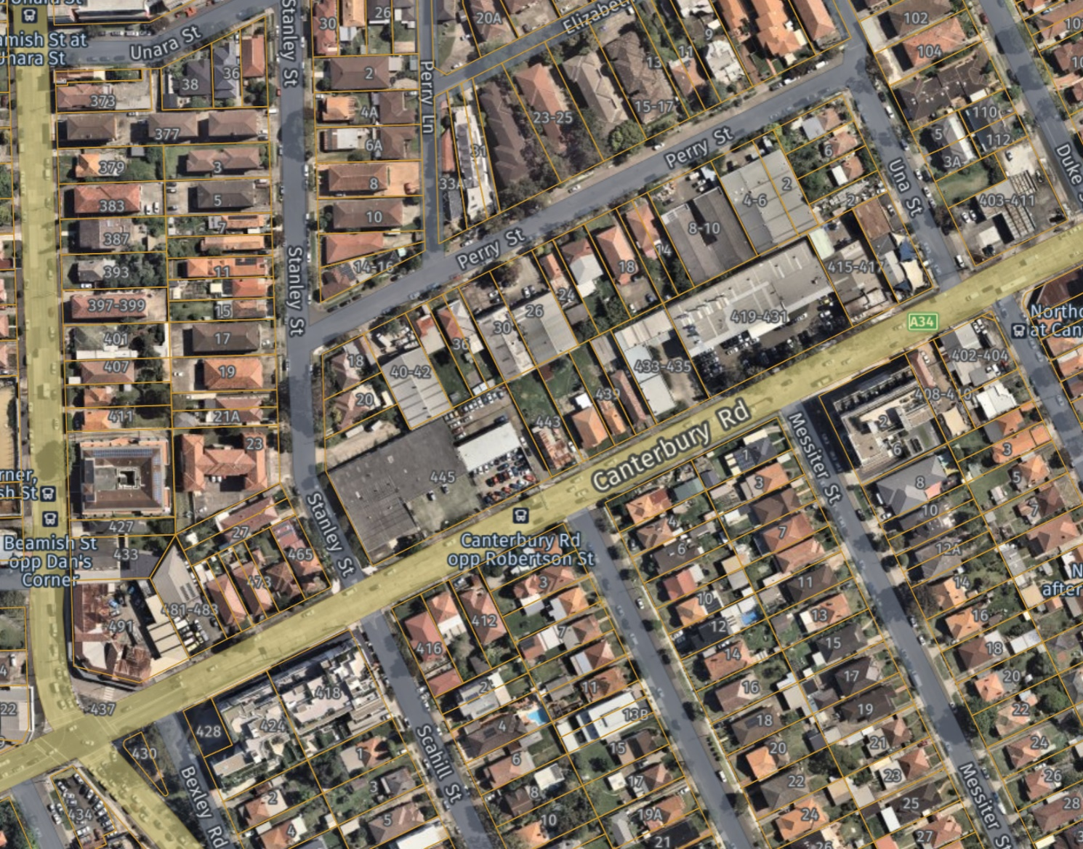

***Figure 1*** *|Aerial of subject site in blue. Nearmap: 28 October 2022*

Occupying Nos 433-435 Canterbury Road is an ‘L-shaped’ concrete panel warehouse with an extensive hardstand area accommodating both on-site car parking and on-site maneuvering areas in association with the use of the site as a kitchen manufacturer. No 437 Canterbury Road is occupied by a single storey rendered dwelling house with a hipped tiled roof and a detached garage and awning situated towards the rear of the site.

The site slopes from the street to the sites north-western boundary (to the rear) representing a fall of approximately 1 in 19. Existing vegetation that occupies the site is restricted to adjacent the warehouse building on No 433-435 Canterbury Road.

The adjoining properties to the north-west are occupied by a two-storey red brick residential flat building at No 18 Perry Street, single storey attached dwellings at Nos 20 and 22 Perry Street and a free standing single storey dwelling with detached outbuilding at No 24 Perry Street. The adjoining property to the south-west is occupied by a single storey detached dwelling while immediately adjoining the site to the north-east, at No 419-431 Canterbury Road, is a prestige accident repair centre.

Of relevance to the assessment of this development application, is that the entire block bounded by Canterbury Road, Stanley Street, Perry Street and Una Street is zoned B6 Enterprise Corridor and is subject to the same building height standard under the Canterbury Local Environmental Plan 2012 as to that which applies to the subject development site.

To the south-east, on the opposite side of Canterbury Road, the properties are zoned R3 Medium Density Residential and are occupied by two single storey dwelling houses, one of which fronts Messiter Street while the other fronts Robertson Street.

The surrounding local area is typically characterised by a mix of land uses including warehouses, commercial developments, shop top housing and detached dwellings. Campsie Railway Station is located approximately 1.2km to the north-west of the site.

**PROPOSED DEVELOPMENT**

Development Application No DA-286/2022 seeks approval to demolish the existing structures that occupy Nos 433-437 Canterbury Road, Campsie and for the construction of a three-storey mixed-use building providing a gym tenancy, floor area dedicated for ‘medical use’, a café and a number of business premises with three levels of basement car parking, and associated landscaping and site works.

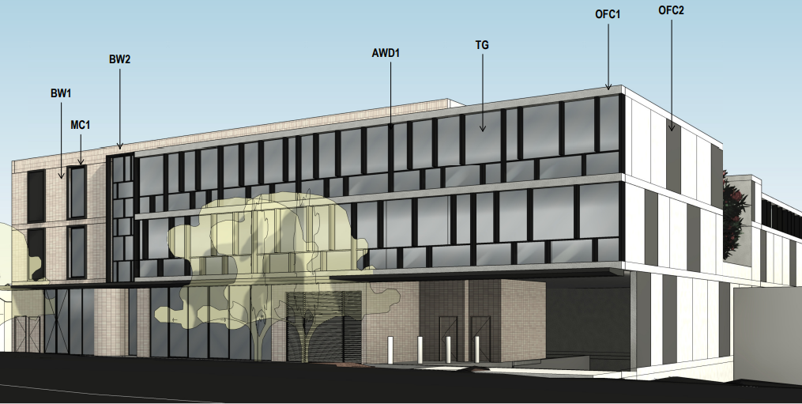

***Figure 2*** *| Architects 3D image of proposed development*

The details of the development are as follows:

|  |  |
| --- | --- |
| **Level** | **Description** |
| Basement Level 3 | * Thirty-eight (38) car parking spaces and twelve (12) bicycle spaces. * Four (4) separate store rooms and two (2) plant rooms. * A central lift core (2 lifts) and 2 sets of fire stairs. |
| Basement Level 2 | * Thirty eight (38) car parking spaces, including 2 accessible spaces. * A central lift core (2 lifts) and 2 sets of fire stairs * Three (3) store rooms, a communication room, a main switch board room, and a plant room. |
| Basement Level 1 | * Thirty six (36) car parking spaces, including 1 accessible space, and five (5) bicycle spaces. * A Hydraulics Plant Room and a Grease Arrestor room. * Three (3) lift cores and 2 sets of fire stairs. |
| Lower Ground Floor | * Three (3) car parking spaces, including 1 accessible space. * A waste room and a medical waste room. * Three (3) lift cores and 2 sets of fire stairs. * Gym tenancy (511m2). |
| Ground Floor | * Two vehicular crossings (separate entry and exit crossover) to Canterbury Road. * A substation chamber. * Two (2) business premises with a combined floor area of (166m2). * A café (53m2). * A medical centre (562m2). * A fire pump room and an accessible WC. * Three (3) lift cores and 2 sets of fire stairs. |
| Level 1 | * Floor area dedicated to a medical use with a combined area of (1,114m2). * Three (3) lift cores, 2 sets of fire stairs and WCs. |
| Level 2 | * Business premises (587m2) and a non trafficable roof. * Plant room, lift core and 2 sets of fire stairs. |

**PREVIOUS APPROVAL**

On 5 March 2020 Council issued Determination Notice No DA-572/2019 approving the demolition of theexisting structures that occupied No 433-437 Canterbury Road, Campsie (being the subject site) and for the construction of a mixed use development for a three storey hotel with 112 rooms, one ground floor commercial tenancy, four levels of basement car parking and associated landscaping.

**STATUTORY CONSIDERATIONS**

When determining this application, the relevant matters listed in Section 4.15(1) of the *Environmental Planning and Assessment Act 1979* must be considered. In this regard, the following environmental planning instruments, development control plans (DCPs), codes and policies are relevant:

1. State Environmental Planning Policy (Planning Systems) 2021
2. State Environmental Planning Policy (Resilience and Hazards) 2021
3. State Environmental Planning Policy (Transport and Infrastructure) 2021
4. Canterbury Local Environmental Plan 2012
5. Draft Canterbury-Bankstown Local Environmental Plan 2020
6. Canterbury Development Control Plan 2012

**SECTION 4.15 ASSESSMENT**

The development application has been assessed against the matters for consideration within Section 4.15(1) of the *Environmental Planning and Assessment Act, 1979* and the following key issues emerged:

***Environmental planning instruments [Section 4.15(1)(a)(i)]***

* ***State Environmental Planning Policy (Planning Systems) 2021***

Clause 2.19(1) of Part 2.4 of SEPP (Planning Systems) 2021 reads as follows;

*Development specified in Schedule 6 is declared to be regionally significant development for the purposes of the Act.*

Schedule 6 of SEPP (Planning Systems) 2021, in part, reads;

***5   Private infrastructure and community facilities over $5 million***

*Development that has a capital investment value of more than $5 million for any of the following purposes—*

*(a)  air transport facilities, electricity generating works, port facilities, rail infrastructure facilities, road infrastructure facilities, sewerage systems, telecommunications facilities, waste or resource management facilities, water supply systems, or wharf or boating facilities,*

*(b)  affordable housing, child care centres, community facilities, correctional centres, educational establishments, group homes,* ***health services facilities*** *or places of public worship.* ***(emphasis added)***

In the event that the CIV of the proposed development exceeds $5 million ($13,280,333.50), the development is defined as being a ‘regionally significant development’ hence the Sydney South Planning Panel are the determining authority. The application is accordingly referred to the Panel for determination.

Council Briefing with the Sydney South Planning Panel

Council attended a Briefing Meeting with Sydney South Planning Panel on 23 August 2022 in relation to this development. The minutes of the Briefing are as follows;

* *Only one vehicular crossing from Canterbury Road to be included to the satisfaction of TfNSW*

As discussed later in this report, TfNSW have provided concurrence to the plans (being the subject of this assessment) that provide a left in and left out access arrangement with splayed driveways separated by a raised kerb.

* *Explore drop-off and loading below street level with lobby access to medical suites*

Drop-off and loading arrangements have been provided below street level on the lower ground floor plan. Lobby access has been provided from this level to the Ground Floor, Level 1 and Level 2.

* *Street level frontage to address Canterbury Road and provide active uses consistent with DCP requirements*

The street level frontage has been activated with a café use and 2 business premises.

* *Configuration of medical suites to be provided*

The Level 1 floor plan does not provide for the configuration of the medical suites rather it refers to the floor now as being used as ‘medical’.

* *Proposed use and hours of operation for top floor tenancy and top floor terrace to be provided*

The applicant has identified that the top floor tenancy will be used as a ‘Commercial Business Office’ with the hours of operation to be 8:00am to 6:00pm. The roof top terrace has been replaced with a non-trafficable roof.

* *Waste storage and pick area needs to be designed to meet Council requirements noting Council’s preference for a heavy rigid vehicle (4.5m head clearance) may not be necessary for the uses proposed if a private waste contractor is employed.*

The applicant has advised that waste collection will be undertaken by a private waste contractor. The proposal provides for suitable access, egress and on-site manoeuvring for an SRV. It is noted that the conditions that have been recommended to be imposed by TfNSW state that ‘*vehicles longer than 6.6 metre in length are to be prohibited from entering the subject site*.’ This in fact limits waste collection to be via a SRV.

* ***State Environmental Planning Policy (Resilience and Hazards) 2021***

Clause 4.6(1) of Chapter 4 of SEPP (Resilience and Hazards) 2021 requires Council to consider whether the land is contaminated prior to granting consent to the carrying out of any development on that land. Should the land be contaminated, Council must be satisfied that the land is suitable in a contaminated state for the proposed use. If the land requires remediation to be undertaken to make it suitable for the proposed use, Council must be satisfied that the land will be remediated before the land is used for that purpose.

Accompanying the development application were the following documents;

1. ‘Geotechnical Desktop Study Report’ prepared by EI Australia, referenced as Report E23242 GA_Rev 3, dated 31 March 2022
2. ‘Detailed Site Investigation’ prepared by EI Australia, referenced as ‘Report E23242.E02.Rev6’, dated 31 March 2022
3. ‘Remediation Action Plan’ prepared by EI Australia, referenced as ‘Report E23242.E06.Rev6’, dated 6 April 2022

These reports contain recommendations regarding future excavation, building foundations and the management of on-site contaminated material. Council’s Environmental Health Officer has reviewed each of these documents and is satisfied, subject to the imposition of suitable conditions of consent, that upon the site being remediated that the site will be suitable for the proposed use having regard to the provisions contained within SEPP (Resilience and Hazards) 2021.

* ***State Environmental Planning Policy (Transport and Infrastructure) 2021***

Frontage to a classified road

As the site has a frontage to a classified road (i.e. Canterbury Road), Clause 2.119 of the SEPP is relevant and requires Council to be satisfied that, where practical, vehicular access to the land is provided by a road other than the classified road.

The subject site only has frontage to Canterbury Road, being a mid-block development site and being bordered to the north by a number of properties fronting Perry Street. The site is therefore unable to provide alternative vehicular access to the site other than from Canterbury Road.

The application was referred to Transport for NSW (TfNSW) with Council being in receipt of correspondence dated 26 October 2022 stating that TfNSW give concurrence to the civil works on Canterbury Road under Section 138 of the *Roads Act 1993* subject to nine (9) conditions being incorporated in any consent issued by Council. None of the conditions require amendments to be undertaken to the development. The conditions have been incorporated into the attached recommended consent notice.

Notwithstanding the above, the Canterbury Road Review (a higher strategic document and therefore subject to the ‘public interest’ provisions of s.4.15 of the *Environmental Planning and Assessment Act 1979*) envisages a laneway to the rear of the site. The entire development observes a minimum 4.5 metre rear setback in order to facilitate a 9m laneway at the rear of the site, with the other half of the 4.5m to be provided in future by the sites to the rear.

Traffic generation

The development also qualifies as ‘traffic generating development’ having regard to Clause 2.122 and Schedule 3 of the SEPP in so far as the proposal provides for more than 50 car parking spaces with access to a classified road.

TfNSW have confirmed that they have no objection to the development on traffic generating grounds.

* ***Canterbury Local Environmental Plan 2012***

This site is zoned B6 Enterprise Corridor under the Canterbury Local Environmental Plan 2012 (the LEP).

Clause 2.3(2) of the LEP states that ‘*the consent authority must have regard to the objectives for development in a zone when determining a development application in respect of land within that zone’.*

The relevant objectives for the B6 Enterprise Corridor are as follows:

* *To promote businesses along main roads and to encourage a mix of compatible uses*
* *To provide a range of employment uses (including business, office, retail and light industrial uses)*
* *To maintain the economic strength of centres by limiting retail activity*
* *To facilitate the revitalisation of Canterbury Road and create an attractive streetscape supported by buildings of a high standard of design*
* *To support urban renewal and a pattern of land use and density that reflects the existing and future capacity of the transport network.*

The proposed development is consistent with the objectives of the B6 zone, by promoting business uses along main roads, by providing a range of uses, by providing various employment opportunities without detracting from the viability of the local centres and by favourably contributing to the emerging streetscape in a manner envisaged by the applicable controls and capacity of the local road network.

The following table provides an assessment of the development application against the key controls and clauses in the Canterbury Local Environmental Plan 2012.

|  |  |  |  |  |  |
| --- | --- | --- | --- | --- | --- |
| **Part 2 Permitted or prohibited development** | | | | | |
|  | **Requirement** | | **Proposal** | | **Complies** |
| 2.1-2.8 Zoning | B6 Enterprise Corridor  **Permitted with consent**  Business premises; Community facilities; Food and drink premises; Garden centres; Hardware and building supplies; Hotel or motel accommodation; Landscaping material supplies; Light industries; Oyster aquaculture; Passenger transport facilities; Plant nurseries; Roads; Tank-based aquaculture; Vehicle sales or hire premises; Warehouse or distribution centres;  Any other development not specified in item 2 or 4. | The mixed-use development comprises:   * Business Premises   (‘Commercial premises’)   * Café   (‘Food and drink premises’)  Each of these uses are Permitted with consent’ in the B6 Enterprise Corridor zone  The development also includes;   * Gym   (‘Recreation facility – indoor’)   * Medical Centre / Use   (‘Health services facility’)  A ‘Recreation facility – indoor’ and a ‘Health services facility’ are **NOT** listed in Item 4 as Prohibited Development. | | Yes. | |
| **Part 4 Principal Development Standards** | | | | | |
| 4.3 Height of Buildings | The maximum height shown for the land on the Height of Buildings Map is 12 metres | | The maximum building height is 11.98m | | Yes. |
| 4.4 Floor Space Ratio | No maximum floor space ratio applies to the site | | N/A | | N/A |
| **Part 6 Local Provisions** | | | | | |
| 6.1 Acid sulfate soils | Before granting consent Council is required to have regard to the presence of acid sulphate soils | | The site is not impacted by Acid Sulphate Soils. | | N/A |
| 6.2 Earthworks | Before granting consent to development including earthworks, the following must be considered:   1. drainage patterns and soil stability   (b) the likely future use or redevelopment of the land,  (c) quality of the fill or the soil to be excavated, or both,  (d) effect of development on existing and likely amenity of adjoining properties,  (e) the source of any fill material and the destination of any excavated material,  (f) the likelihood of disturbing relics,  (g) the potential for adverse impacts on, any waterway, drinking water catchment or environmentally sensitive area,  (h) appropriate measures proposed to avoid, minimise or mitigate the impacts of the development. | | A geotechnical report accompanied the DA. Amongst other things, it investigated the existing soil conditions, recommendations relating to excavation retention and retaining walls, and the depth of the groundwater.  The report recommended that dilapidation reports for the adjoining developments be obtained which has been conditioned accordingly.  A further condition has been recommended requiring the final geotech report to contain appropriate measures be implemented around dewatering of the site during construction. | | Yes. |
| 6.4 Stormwater Management | Consent must not be granted unless:   1. the development is designed to maximise the use of water permeable surfaces on the land 2. the development includes on-site detention, if practical, as an alternative supply to mains water   (c) the development avoids significant impacts of run-off on adjoining land or the environment or minimises and mitigates impacts. | | The applicant proposes to dispose of stormwater via an existing piped drainage system that adjoins the sites rear boundary such that the stormwater enters Council’s drainage system at Perry Street. Confirmation that access to this piped system is legally obtained and that stormwater entering this system is able to be accommodated, is the subject of deferred commencement conditions | | Subject to conditions through a deferred commencement consent |
| 6.6 Essential Services | Essential services must be available or adequate arrangements have been made to make them available, including:   * the supply of water; * the supply of electricity; * the disposal and - management of sewage; * stormwater drainage or on-site conservation; * suitable vehicular access. | | The proposal provides for a main switch board, a grease arrestor, a number of plant rooms including a hydraulic plant room, a fire pump room, etc.  A 4.2m x 4.6m substation chamber has been provided adjacent the driveway and is setback consistent with the alignment of the development ensuring the 3m front setback is free of any building elements. | | Yes. |

***Section 4.15(1)(a)(ii) Any proposed instrument that is or has been the subject of public consultation under this Act and that has been notified to the consent authority***

The draft Canterbury Bankstown Local Environmental Plan 2020 applies to the subject site. The Draft LEP has been publicly exhibited, was adopted by the Canterbury Bankstown Local Planning Panel on 30 June 2020, and is in the process of being finalised by the Department of Planning. While the draft instrument proposes the introduction of some additional provisions, in the most part, the Draft LEP provides for an administrative conversion of both the Bankstown Local Environmental Plan 2015 and the Canterbury Local Environmental Plan 2012 into a combined document under the Standard Instrument LEP template. The development is not inconsistent with the provisions contained within the draft consolidated instrument.

It should be noted that the consolidated instrument does not propose to introduce a FSR control in relation to these sites. Therefore, the building height standard, that is within the current instrument (and is proposed to remain the same in the consolidated instrument), is essentially the only numerical development standard controlling the bulk and scale of the development.

***Section 4.15(1)(a)(iii) Any development control plan***

1. **Canterbury Development Control Plan 2012**

An assessment against the relevant provisions contained within Part B ‘General Controls’ and Part D ‘Business Centres’ of the Canterbury Development Control Plan 2012 is provided in the tables below:

|  |  |  |  |
| --- | --- | --- | --- |
| **Standard** | **Requirement** | **Proposal** | **Complies** |
| **Part B1 Transport and Parking** | | | |
| B1.3.1  General Parking Rates | Shops, Business and Retail Premises   * 1 space per 40m2 GFA (<120m2). * 1 space per 30m2 GFA (120m2 – 1,000m2)   Restaurants (Café)   * Less than 120m2 – 1 space per 40m2 GFA   Recreation Facilities (Gym)   * A Traffic and Parking Assessment Report with a survey of similar facilities is required.   Medical Centres   * 1 space per 25m2 GFA | Lower ground floor  Gym (511m2) = According to the Traffic and Parking Impact Assessment submitted with the DA, the *RTA Guide to Traffic Generating Developments* identifies the parking rate for a gym as being a min. of 4.5 spaces per 100m2 GFA = 23 spaces  Ground floor  Medical centre (562m2) = 22.5 spaces  Café (53m2) = 1.3 spaces  Business premises (54m2) = 1.3 spaces  Business Premises (112m2) = 2.8 spaces  Level 1  Medical centre (1,114m2) = 44.5 spaces  Level 2  Business premises (587m2) = 19.5 spaces  **Required = 114.5 spaces**  **Provided = 115 spaces** | Yes. |
| B1.3.2  Accessible Parking Rates | For ‘commercial’ development provide;   * 1 accessible space per 50 spaces for employees * 1 accessible space per 50 spaces for visitors   Be designed in accordance with AS2890.1 | Required = 4 spaces  A total of four (4) accessible space are provided within the basement | Yes. |
|  | **Bicycle Parking**  Business premises   * Staff: Min. 1 space per 300m2 GFA. * Patrons: Min. 1 space per 500m2 GFA over 1000m2   Restaurant (café)   * Staff: Min. 1 space per 100m2 GFA over 100m2. * Patrons: Min. 2 spaces   Recreation Facilities   * Staff: Minimum 1 space per 400m2. * Visitors: 1 space per 200m2 | Required = 8 bicycle spaces  A total of 12 staff bicycle spaces are provided on Basement Level 3 and 5 visitor bicycle spaces are provided on Basement Level 1. | Yes. |
| B1.3.3  Loading and Service Bay Provision | Loading and service bays required to be determined on merit. | The loading bay provided on the lower ground floor is of sufficient size to accommodate the parking of a SRV in addition to allowing for vehicles to access and egress the basement levels. The necessary head height clearances for a SRV have been confirmed as have the required swept paths.  A condition of consent requires the preparation of a Plan of Management which is to stipulate that waste collection, unloading / loading and other service requirements are to occur outside peak periods. | Yes. |

Originally the applicant sought to provide eighteen (18) health consulting rooms on Level 1. The plans, subject to this assessment, identify the use of Level 1 as now ‘Medical’ meaning that a minimum of 44 car parking spaces are required to be provided for this use. For comparative purposes, should the applicant seek to revert back to use this floor as ‘health consulting rooms’ (consistent with what was originally proposed), the car parking demand would be 36 spaces. In essence, the provision of 44 car parking spaces could allow for twenty-two (22) health consulting rooms.

|  |  |  |  |
| --- | --- | --- | --- |
| **Part B2 Landscaping and Part B3 Tree Preservation** | | | |
| B2.2  Landscape Plan | A Landscape Plan is required to accompany the development application | A landscape plan prepared by Canvas Landscape Architects was included in the suite of documents accompanying the development application. | Yes. |
| B2.3.3  Trees and Canopy Coverage | Front and rear setbacks are to have at least 1 major canopy tree for every 12m of front and rear boundary width. | A condition of consent has been recommended to meet the requirements of this control. | Yes. |
| B3  Tree Preservation | Retain trees and canopy cover where possible | The site is devoid of any vegetation worthy of being retained. Trees on the adjoining properties to the rear will not be impacted by the development. | Yes. |

|  |  |  |  |
| --- | --- | --- | --- |
| **Part B5 Stormwater and Flood Management** | | | |
| B5.2  Stormwater and Flood infrastructure | The stormwater drainage plan is to address all the issues outlined in the On-Site Stormwater Detention Checklist contained in Appendix 1 – Engineering Specifications | The applicant proposes to dispose of stormwater via an existing piped drainage system that adjoins the sites rear boundary such that the stormwater enters Council’s drainage system at Perry Street. Confirmation that access to this piped system is legally obtained and that stormwater entering this system is able to be accommodated, is the subject of deferred commencement conditions | Subject to conditions through a deferred commencement consent |

|  |  |  |  |
| --- | --- | --- | --- |
| **Part B7 Crime Prevention and Safety** | | | |
| B7.2.1  Surveillance | Avoid blind corners in pathways, stairwells, hallways and car parks | The proposed use of CCTV, convex mirrors, electronic access with intercom and increased lighting will increase surveillance and security at the premises. | Yes. |
| B7.2.2  Access Control | Provide clear entry points and ensure buildings are clearly identified by street numbers | The development provides for easily identifiable and practical vehicular and pedestrian access arrangements providing confidence for visitors arriving at the site. | Yes. |
| B7.2.3  Territorial Reinforcement | Clearly define spaces to express a sense of ownership and use materials that reduce the opportunity for vandalism | A high use of glazed elements and the absence of any large blank walls not only increases site surveillance but also reduces opportunities for vandalism and graffiti. | Yes. |

|  |  |  |  |
| --- | --- | --- | --- |
| **Part B9 Waste** | | | |
| B9.2  Waste Management Plan (Demolition and Construction Phases) | Submit a waste management plan in relation to the waste that will be generated in the demolition and construction phase. | A Waste Management Plan prepared by Dickens Solutions Pty Ltd was included in the suite of documents that accompanied the development application. The Plan had regard to the appropriate and suitable disposal of waste generated at the demolition and construction phases. | Yes. |
| B9.3  Waste Management Plan (Ongoing) | Submit a waste management plan for the ongoing use of the development once completed. | The Waste Management Plan has had suitable regard to the amount of ongoing waste that will be generated by the proposed uses. | Yes. |
| B9.5  Waste Storage for Non-Residential Development | That sufficient area is available on site and furthermore that it is accessible for waste collection | A waste storage area is provided on the lower ground floor accommodating general and recyclable waste. A medical waste room is also provided on this level. The applicant seeks to use private contractors to collect the waste generated by the ongoing operation of the uses within the development by a SRV. | Yes. |
| B9.6  Design and Access Waste Bin Storage Areas | Waste bin storage areas and bin presentation areas are to be capable of accommodating the allocated number of waste containers | The waste storage areas are accessible with 2m wide access doors. The size of the waste room is be increased so as to cater for the storage of waste that is likely to be generated during the ongoing operation of the uses within the development. | Yes.  Subject to a condition that requires the ‘waste room’ on the lower ground floor level to be increased in size |

Council’s Resource Recovery Unit recommended, having regard to the latest set of plans, that the waste storage area is to be of sufficient size to fit and manoeuvre 6 x 1100L bins side by side (not stacked). As indicated by TFNSW in their correspondence of 26 October 2022, ‘*vehicles longer than 6.6 metres in length are to be prohibited from entering the site’* hence access for waste collection purposes is confined to a SRV. Conditions of consent have been recommended ensuring that the waste storage room is of sufficient size (to accommodate the waste generated by the users of the building) and the wording is of sufficient flexibility so as to accommodate the collection of the waste by a SRV.

|  |  |  |  |
| --- | --- | --- | --- |
| **Standard** | **Requirement** | **Proposal** | **Complies** |
| **Part D Business Centres – General** | | | |
| D1.2.2  Isolated Sites | Ensure that the land adjoining is not left sterilised or isolated | Approval of the development will not result in any adjoining properties being isolated. | Yes. |
| D1.3.2  Height | The maximum permissible height is that as prescribed in the CLEP 2012 (i.e. 12 metres) | The building has a maximum height of 11.98m. | Yes. |
| D1.3.3  Floor to Ceiling Height | Ground floor min. 3.3m  Other floors min. 3m  Car parking is required to have a floor to ceiling height in accordance with AS2890.1  Floor to ceiling heights may be increased to meet the requirements of the intended use, but must not breach the maximum LEP height. | The following floor to ceiling heights are proposed;  LGF – 3m (gymnasium)  GF – 3.842m  1st – 3.035m  2nd – 3.035m  Achieved.  Floor to ceiling heights of the ground floor, 1st and 2nd floor exceed the minimum requirements however the development does not exceed the maximum LEP height. | See below for discussion on the proposed 3m floor to ceiling height of the gymnasium |
| D1.3.4  Setbacks | Minimum front setback for 1-3 storey buildings is 3 metres from the street boundary. | A minimum 3 metre front setback is provided. | Yes. |
| Min. 3m setback to the street boundary for all basement levels | A minimum 3m setback is provided for all basement levels | Yes. |
| Nil setbacks can be provided to the side boundaries | Nil setback provided to the eastern and western boundaries | Yes. |
| A nil setback can be provided to the rear boundary. | A minimum 4.5 metre setback is provided to the rear boundary | Yes. |
| D1.3.5  Building Depth | Commercial premises must have a:  Min. depth of 10m  Max. ‘street frontage wall length’ of 50m | The depth of the building exceeds 10m  The ‘street frontage wall length’ is less than 50m | Yes.  Yes. |
| D1.4.1  Orientation and Layout | Design and orient development to maximise solar access and natural light, without unduly increasing the building’s heat load.  Design and site development to avoid casting shadows onto neighbouring dwelling’s primary living area, private open space and solar cells. | Being located on the northern side of the street the tenancies gain excellent solar access.  Adjoining the site to the south-west, the dwelling receives adequate solar access to the rear of the dwelling. It should be noted that the site to the west is similarly zoned B6 Enterprise Corridor | Yes.  Yes. |
| D1.4.2  Ground Level Interface | Provide entries for service activities to rear of the buildings.  Provide an awning over the entry to contribute to the legibility of the development and the public domain.  Min width 3m  Height 3.2m – 4.2m | In the absence of a rear lane, service activities are provided within the basement.  Awning provided along the front of the development with a minimum height of 3.6 metres. | Yes.  Yes. |
| D1.4.3  Façade Treatment | Avoid long spans of blank walls along street frontages.  Use a harmonious range of high quality materials, finishes and detailing. | Varied materials and finishes have been incorporated into the design. The façade treatment is mixed and varied with clear delineation achieved between the ground floor level and the 2 levels above. | Yes. |
| D1.4.4  Roof Design | Roofs must not exceed a pitch of 10 degrees.  Relate roof design to the desired built form and context. | The roof has a pitch of less than 10 degrees and suitably relates to the built form and context of the local area. | Yes |
| D1.4.6  Laneways | To facilitate a laneway along the rear of the site | The Canterbury Road Review (a higher-level strategic document) identifies a laneway along the rear of the site. The building and basement have been setback 4.5m in order to realise this laneway in the future. | Yes. |
| D1.4.7  Building Services | Integrate systems, services and utility areas (such as plant rooms, hydrants, equipment and the like) with the design of the development | The proposal provides for a main switch board, a grease arrestor, a number of plant rooms including a hydraulic plant room, a fire pump room, etc. These are all provided in the basement.  A 4.2m x 4.6m substation chamber has been provided adjacent the driveway and is setback consistent with the alignment of the development ensuring the 3m front setback is free of any building elements. | Yes. |
| D6  Canterbury Road Structure Plan | Urban Enterprise: B6 – Enterprise Corridor  Comprise buildings ranging from 1-3 storeys with varying street alignments. Street level uses may include light industrial, large floor plate retail/bulky goods, showrooms and commercial. Upper levels may incorporate ancillary and/or commercial uses. This character area predominantly applies to previous employment zones and is intended to maintain employment functions in a more street oriented and contemporary manner. There will be no new residential in this character area. | The development presents to Canterbury Road as a 3 storey building and accommodates a number of land use types that will facilitate employment opportunities. As the assessment report has demonstrated, the development complies with the controls that are contained within the various layers of planning legislation that apply to this site and this development. | Yes. |

D1.3.3 Floor to Ceiling Height

Control C1(a) within D1.3.3 of Part D of the CDCP 2012 reads as follows;

*Provide a minimum 3.3m floor to ceiling height for the ground floor.*

The ‘ground floor’ has a floor to ceiling height greater than 3.3m however the gymnasium at the ‘lower ground floor’ (at the rear) has a floor to ceiling height of 3m. The objective of this control reads as follows;

*O1 To ensure floor to ceiling height is adequate for the operation of the intended and potential use.*

With respect to the ‘intended use’, being a gymnasium, a 3m floor to ceiling height is compliant with the BCA. With respect to ‘potential’ uses, the 3m floor to ceiling height would still allow for a number of land uses as permitted by the LEP. The development provides for nearly 800sqm of leasable ‘ground floor’ area within four (4) separate tenancies that satisfies the minimum floor to ceiling height of 3.3m. The purpose, objective and intent of the control is very much realised in this design.

***Section 4.15(1)(a)(iiia) Planning agreements***

A planning agreement has not been entered into under Section 7.4 of the *Environmental Planning and Assessment Act 1979*, nor has the applicant offered to enter into a draft planning agreement.

***Section 4.15(1)(a)(iv) The regulations [section 79C(1)(a)(iv)]***

The proposed development is consistent with the relevant provisions of the Environmental Planning and Assessment Regulation 2021.

***Section 4.15 (1) (b) – The likely impacts of the development, including environmental impacts on both the natural and built environments, and social and economic impacts on the locality***

*Environmental impacts on the natural environment*

* The site does not contain any vegetation that is worthy of being retained.
* The proposed method of stormwater disposal will not impact the adjoining developments.

*Environmental impacts on the built environment*

* The existing structures that occupy the site are old and outdated. The development is of a scale and built form that is envisaged by the planning controls.
* The built form will retain solar access to the adjoining dwelling to the south-west and, while out of scale with this dwelling, is consistent with that which is emerging along the Canterbury Road streetscape.
* As indicated earlier in the report, the sites to the immediate north are occupied by residential developments hence occupiers of these buildings will be subject to a visual impact in addition to a privacy impact. Given the zoning of the land and the age, in particular, of the adjoining dwellings, it should be noted that the area is in transition with these sites over time to be developed to a scale comparable to that which is proposed.

*Social impacts on the locality*

* The development provides for exercise, health and medical land uses that will positively contribute to the well-being of the residents of the broader locality.
* The development was referred to Council’s Community Safety Officer who has advised that the *‘… proposed development has sufficiently considered community safety and crime prevention through design principles*.’
* The gymnasium is proposed to operate 24 hours. Accompanying the DA was an acoustic report in which it had regard to the impact this use would have on the residents to the rear. Subject to the implementation of the recommendations provided in Section 7 of the acoustic report, *‘the noise generated by the proposed gym will be well below the noise trigger level at the boundary of the nearest residential receivers.’*

*Economic impacts on the locality*

* The development will provide numerous employment opportunities given the wide and varied land uses proposed in addition to the opportunities provided at the construction stage.

***Section 4.15 (1) (c) The suitability of the site***

The site is considered suitable for the proposed development. The development results in an appropriate built form for the site, being consistent with that envisaged by the planning controls. No adverse impacts have been identified to suggest that the site would not be suitable for the development that is proposed.

***Section 4.15 (1) (d) – Any submissions made in accordance with this Act or the Regulations***

The application was advertised for a period of twenty-one (21) days from 1 June 2022 to 21 June 2022 in accordance with Council’s Community Participation Plan. At the time of preparing this report, Council is not in receipt of any submissions.

***Section 4.15(1)(e) ­ The public interest***

The public interest is best served by the consistent application of the requirements of the relevant Environmental Planning Instruments and by the consent authority ensuring that any adverse impacts on the surrounding area and environment are avoided. The proposed development achieves a high level of compliance with the suite of planning controls applicable to the application and there have not been any environmental issues identified with the proposal. The proposal is therefore consistent with maintaining the public interest.

**CONCLUSION**

The development application has been assessed having regard to the matters for consideration contained in Section 4.15(1) of the *Environmental Planning and Assessment Act 1979*. As the report has demonstrated, the proposal was found to have satisfied the various layers of planning legislation that apply and provides for no environmental impacts on the immediate locality.

**RECOMMENDATION**

It is recommended that the application be approved, a deferred commencement basis, requiring the applicant to demonstrate that the existing adjoining piped stormwater system is able to accommodate stormwater from this site and that the necessary easements are in place, prior to the consent becoming operative.